URL: https://www.maheshwarimpex.com/product/moroccan-and-kitchen-tiles-bangalore

Keyword: Kitchen tiles in Bangalore

**H2 - Premium Kitchen Tiles in Bangalore**

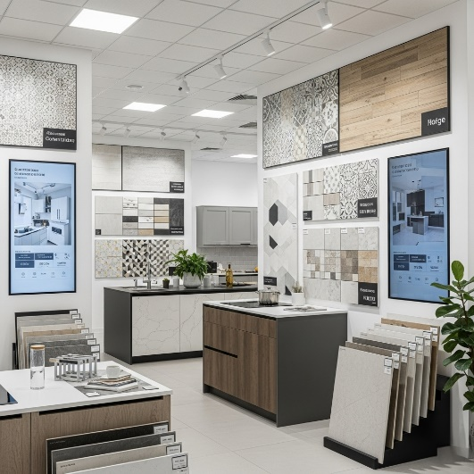

The kitchen is the heart of every home. It a space filled with flavours, spices & cherished moments. At [Maheshwari Impex](https://www.maheshwarimpex.com/) we believe every kitchen is hub of connection & connectivity a place where homes come alive and family’s bond over shared moment, so we design a premium [Kitchen Tiles in Bangalore](https://www.maheshwarimpex.com/contactus) featuring imaginative, stylish & human centric designs that bring you warmth & personality to your space with the guidance of our experts you can bring your dream kitchen into reality.

Choose from an extensive range of Kitchen Tiles in Bangalore with colours, designs, styles That match your taste and preference. Trusted by the thousands of families across the Bangalore, Karnataka.

Explore our [Wall cladding](https://www.maheshwarimpex.com/gallery/laterite-cladding-in-bangalore), [Floor tiles](https://www.maheshwarimpex.com/product/kota-stones) & [Wall Tiles in Bangalore](https://www.maheshwarimpex.com/product/kota-stones) and get personalized advice from our experts to select the perfect tiles for your space. Don’t miss out on our best offers!

**Url:** https://www.maheshwarimpex.com/product/quartz

**Keywords:** Quartz Countertops in Bangalore

**H1 - Top-grade quartz countertops in Bangalore**

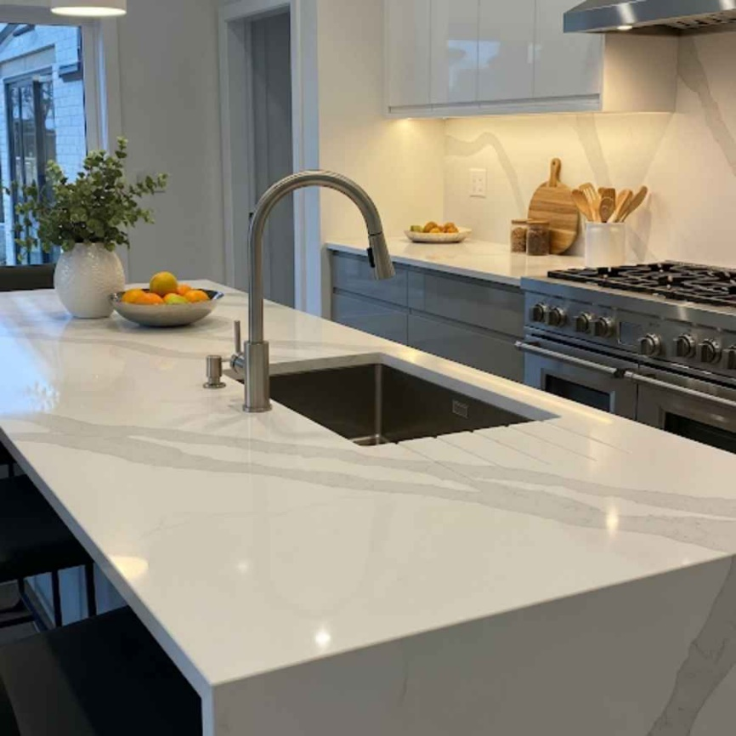

**Image Title: quartz countertops in Bangalore**

**Alt Tag:** A modern kitchen featuring an island and countertops made of white quartz with Gray veining

Every Home is dream and every detail matters, especially when it comes to countertops. At [Maheshwari impex](https://www.maheshwarimpex.com/about-us) we bring you a top-grade **quartz countertop in Bangalore**, for Kitchen & Bathroom where memories are made conversations happen in their daily life. Choosing the right countertops can make these spaces truly special adding both beauty & functionality

trusted by the homeowners & the Interior designers. Our countertops combine elegance, durability & high quality craftmanship without any compromise with a wide range of colours, patterns & finishes you can create a space that reflects your style while standing up to everyday use.  
**Get Your** [Free Expert Consultation](https://www.maheshwarimpex.com/contactus) **Today** and take the first step toward your dream kitchen or bathroom.

[**Talk to an Expert**](https://www.maheshwarimpex.com/contactus)

**Features of Countertops**

• **Wide Range of colours & Patters**; white, blacks or vibrant hues to match any décor.

• **Durability**: Made from one of the hardest minerals, Quarts resists scratches & cracks

• **Low Maintenance**: No sealing is needed, making cleaning effortless

• **Stain & Bacteria resistant:** Most suitable for hygienic Kitchens & Bathrooms

• **Uniform & Cohesive Look:** Reliable patterns and colours provide a polished, elegant finish

• **Heat Resistant**: Best for Kitchens.

**Why Quarts Countertops?**

Quartz countertops Unite [beauty and practicality](https://www.maheshwarimpex.com/gallery/rustic-stones-in-bangalore). They provide:

* A **long-lasting, elegant surface** that enhances your home’s appearance
* **Easy maintenance** without compromising on style.
* **Hygienic, safe surfaces** resistant to stains and virus.
* The perfect solution for the **new home construction** & **renovation.**

**Why Maheshwari Impex?**

Trusted by the thousands of families across the Bangalore, Karnataka. **Maheshwari impex** delivers a high quality of kitchen & bathroom tiles solutions. Here why homeowners choose us.

* **Experts Guidance**: Our Experts assist you to select the ideal quartz countertops for your dream home.
* **Premium Quality**: We offer only finest quartz materials best for durability & style.
* **Wide Selection**: Numerous colour designs & patterns which suits your taste.
* **Customer satisfaction**: we are pleasure to help you from selection to delivery.

**Quartz Countertops: Pricing & Purchase Guide**

At [**Maheshwari Impex**](https://www.maheshwarimpex.com/contactus), we make your choice & buying of Quartz countertop very simple & transparent.

**Expert Consultation**: Visit our showroom or contact our expert to discuss your style preferences, functional needs, and budget.

**Selection Made Easy**: Choose the right colour, pattern & finishes that perfectly match your home space

**Pricing**: Price may differ on the quartz countertops size, colour & style based on that we provide a personalised quote on your requirements.

**Seamless Ordering**: After your choice, our team guides you through the next process, ensuring clarity and assurance.

**Delivery**: We handle safest delivery to a trusted hand.

**Take your First Step: towards buying quartz countertops in Bangalore**

[Talk to an Expert](https://www.maheshwarimpex.com/contactus) or [Visit Us](https://www.maheshwarimpex.com/new-stocks) Today to Nearest Bangalore showroom explore our full range of quartz countertops, get personalized Guidance from our experts, and take advantage of exclusive offers. Make your home not just functional, but truly special.